Year 11 Mathematics Specialist

2018 Revision Assignment 2

**Take Home**

***Instructions:*** *to be completed at home, Calculators are permitted.*

Time Allocation: 2 weeks (holiday), due ___/___/2018 Total Marks: 38 marks

1. (6 marks: 3,3)

Let the complex numbers $u=2+ki$ and $v=-5+12i$, where k is a real number.

Determine all possible values of k if:

${\left[Im\left(u\right)\right]}^{2}=Im(v)$

$\frac{6u}{v}=-i$

1. (6 marks: 1, 1, 2, 2)

A class has 50 students.

1. How many students need to be chosen at random to ensure that there are:
2. Two students who are born on the same day of the week?
3. Five students who are born on the same day of the week
4. There are at least x students who are born on the same day of the week.

Find x, justify your answer

1. There must be at least one day of the week which the birth day of no more than y students. Find y, justify your answer.
2. (3 marks)

Given that |**a|=** 30 and |**b**|=15, find with reasons the maximum value and minimum value of **a.b**.

1. (4 marks)

ABCD is a quadrilateral.

<DAB + <DCB = 180

<ADC + <ABC =180

Prove that there is a circle that passes through A, B, C and D.

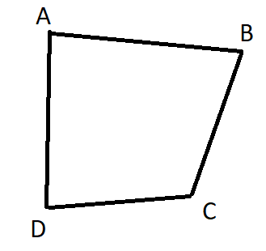

1. (9 marks: 3 each)
2. Prove that $\sqrt{1-\cos{x}}=\sqrt{2}\sin{\frac{x}{2}}$
3. Prove that $\frac{\sin{x}}{1+\cos{x}}=\tan{\frac{x}{2}}$
4. Prove that $\tan^{2}{\frac{3x}{2}}=\frac{1-\cos{3x}}{1+\cos{3x}}$
5. (6 marks: 3,3)

A trigonometric function has the equation $y=-4\sin\left(2x+30\right), for 0≤x≤360$. Use an algebraic method to find:

1. The maximum value for y and the corresponding value(s) for x.
2. The minimum value for y and the corresponding value(s) for x.
3. (4 marks)

Let **X** be an n×1 matric, **A** be a n×n matrix and ƛ be a real non-zero constant.

Given that $A X=ƛX$, prove that $\left|A-ƛI\right|=0$

End of Test